**CS-114 - Fundamental of Programing**

Lab Manual # 07

Lab Tasks

**Course Instructor:** Khawaja Fahad Iqbal

**Lab Instructor:** Muhammad Affan

**Student Name:** Muhammad Talha Kashif

**CMS ID:** 454135

#include<iostream>

using namespace std;

Lab Task 1

int main() {

int num[10];

for(int i=0;i<10;i++)

{

cout<<"Enter number for ["<<i<<"] place of array: ";

cin>>num[i];

}

for(int i=0;i<10;i++)

{

cout<<num[i]<<" ";

}

return 0;

}

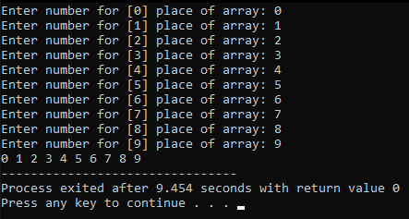

#include<iostream>

Lab Task 2

using namespace std;

int main() {

int num[5];

for(int i=0;i<5;i++)

{

cout<<"Enter number for ["<<i<<"] place of array: ";

cin>>num[i];

}

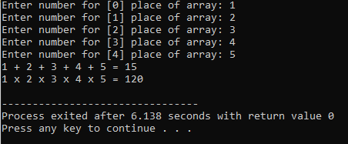 cout<<num[0];

for(int i=1;i<5;i++)

{

cout<<" + "<<num[i];

}

int sum=0;

for(int i=0;i<5;i++)

{

sum=sum+num[i];

}

cout<<" = "<<sum<<endl;

cout<<num[0];

for(int i=1;i<5;i++)

{

cout<<" x "<<num[i];

}

int product=1;

}

cout<<" = "<<product<<endl;

return 0;

}

for(int i=0;i<5;i++)

{

product=product*num[i];

#include <iostream>

Lab Task 3

using namespace std;

int main(){

int x;

cout<<"Enter the size of the longest row in the diamond: ";

cin>>x;

if(x%2==0){

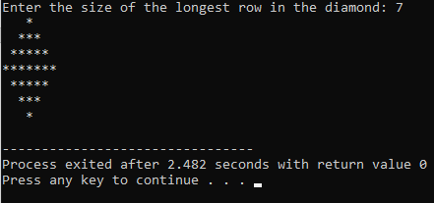 x++;

}

int h=(x+1)/2;

const int size=x;

char diamond[size];

for(int i=0;i<size;++i){

diamond[i]='*';

}

for(int i=0;i<h;++i){

for(int j=0;j<h-i-1;++j){

cout<<' ';

}

for(int k=0;k<2*i+1;++k){

cout<<diamond[k];

}

cout<<' ';

}

for(int k=0;k<2*(i+1)-1;++k){

cout<<diamond[k];

}

cout<<endl;

}

}

cout<<endl;

}

for(int i=0;i<size;++i){

diamond[i]='*';

}

for(int i=h-2;i>=0;--i){

for(int j=0;j<h-i-1;++j){